AMMAR
Machine Learning / AI

Decision Tree — Heart Failure Death Event Prediction

Objective
To build a Decision Tree classifier to predict the Death Event (mortality) of heart failure patients using clinical features. The model was trained in Python and evaluated using accuracy, ROC-AUC, and feature importance.

Dataset Overview
- Dataset: Heart Failure Clinical Records (UCI / Kaggle)
- Total Samples: 299 patients | Test Set: ~60 samples
- Target Variable: DEATH_EVENT (0 = Survived, 1 = Died)
- Features: 12 clinical variables including age, serum creatinine, ejection fraction, serum sodium, platelets, etc.

Code
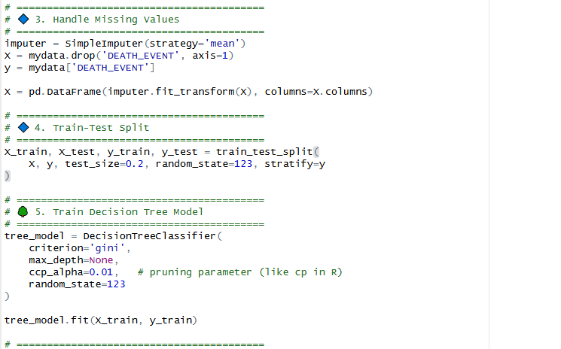

Model Performance
Metric | Value | Metric | Value
Accuracy | 83.3% | AUC Score | 0.843
Precision | ~81% | Recall | ~79%

Decision Tree Visualization
The tree splits first on time ≤ 73.5 (follow-up period), then on serum_creatinine and ejection_fraction. Blue nodes represent survived (class 0) and orange nodes represent death (class 1).

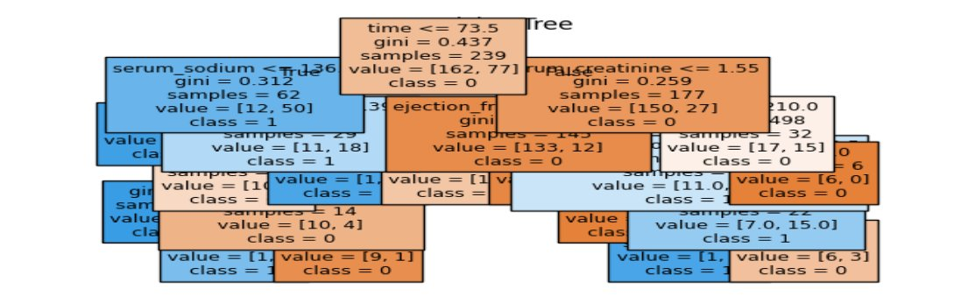
Figure 1: Decision Tree — Heart Failure Death Event (Root: time ≤ 73.5)

Feature Importance  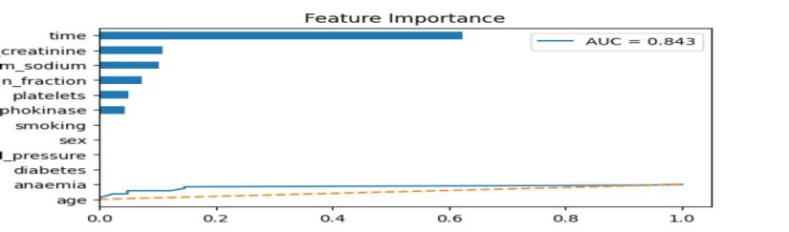  Fig 2: time is the most important feature (0.63) | ROC Curve (AUC = 0.843)  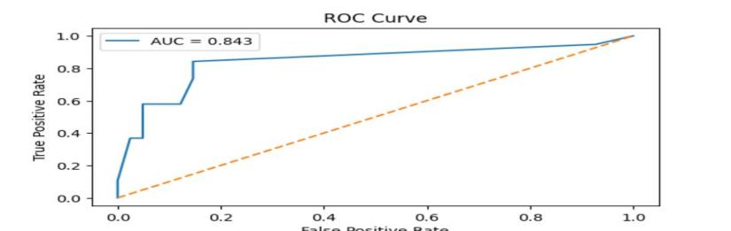  Fig 3: AUC = 0.843 — strong classifier performance

Key Findings
- time (follow-up period) is by far the most important predictor of death — importance score 0.63.
- serum_creatinine and serum_sodium are the next most influential clinical features.
- AUC = 0.843 indicates the model has strong discriminating ability between survivors and non-survivors.
- The Decision Tree is interpretable — clinicians can follow the branches to understand predictions.

Conclusion: The Decision Tree model achieved 83.3% accuracy and AUC of 0.843 in predicting heart failure death events. The follow-up time and serum creatinine level are the strongest clinical predictors of mortality.

— End of Assignment | Submitted by: Ammar —

